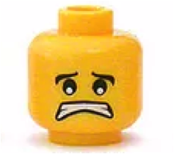../../../../Desktop/thumbs%20up%20facebook.jpg../../../../Desktop/thumbs%20up%20facebook.jpg

I used appropriate classroom language.

I followed the classroom rules.

I followed the teacher’s directions.

I was not distracted and did not distract others.

**Check off how well you think you did for each action.**

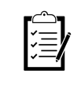

**Behavior**

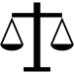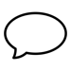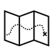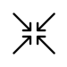

X

I can

do better



I used appropriate classroom language.

I followed the classroom rules.

I followed the teacher’s directions.

I was not distracted and did not distract others.

**Check off how well you think you did for each action.**



**Behavior**



X

I can

do better



Yes!

I did it!

Yes!

I did it!

**Self-Monitoring Checklist**

**Self-Monitoring Checklist**

Name:

Date:

Name:

Date:

