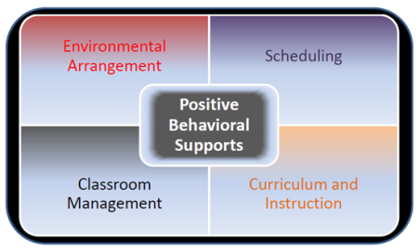
21st Century Learning Environments
Reflection Tool
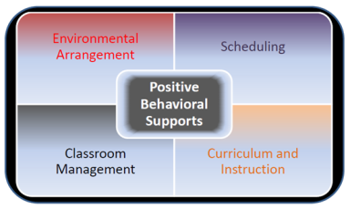
A. ENVIRONMENTAL ARRANGEMENT
A-1 | Each area within the learning environment is organized in a manner that promotes learning and independence.
 | Are the walls, floors, and furniture clean, in good repair, and free from hazards?
Does the physical structure of the learning environment support student learning and behavior during:
- 1:1 teaching? Y/N
- Small group instruction? Y/N
- Large group instruction? Y/N
- Independent work? Y/N
Is increased stationary physical structure (strategic placement of desk, dividers, partitions, etc.) needed such as:
3-sided, 2-sided, or an open physical structure?
 | Is increased portable physical structure (portable screen, portable divider, portable desk-top study carrel, etc.) needed to support learning/behavior/independence during targeted times of the day?
 | Would a change in the traffic flow of any instructional areas in the classroom be helpful for students?
A-2 | Each instructional area within the learning environment is clearly defined, readily apparent, and labeled for specific instructional tasks (whole group, small group, independent work, break/leisure, learning centers, etc…).
 | Are specific and distinct instructional areas (placement of furniture, use of rugs, taped outlines/visual cues on the floor, labels, color coding, etc.) visually clear to the students?
 | Are areas for the students’ personal belongings (lunch box, snack items, book bag, work supplies, personal items, finished work, etc.) and instructional materials visually clear, well organized and easily accessible? Do all students have secure and adequate spaces for personal storage?
A-3 | Arrangement of the areas within the learning environment allows for continuous supervision of all students at all times.
 | Does the room arrangement allow for clear and ongoing staff supervision of students throughout the day?
 | Is staff stationed in the most effective location to provide ongoing supervision of all students?
A-4 | Furniture, learning materials, and sensory items are developmentally and age appropriate, organized, and readily accessible for student use.
 | Is the furniture (desk, tables, chairs) the appropriate size/shape/etc. for students?
 | Is optional seating available for students that have sensory needs?
 | Are sensory materials available for students and accessible when needed? How does a student request sensory materials if the items are not accessible?
 | Are instructional materials organized, labeled and waiting for each instructional activity?
If appropriate to the student population:
A-5 | An area within the learning environment is clearly designated, prepared, and available for self-calming and individual sensory needs, including an individualized data collection procedure.
 | Are available sensory materials appropriate for this student?
 | Is the self-calming area of the classroom in the best location for this student’s use? Is the area relaxing and inviting?
 | Has the student been provided with an individualized visual self-calming sequence and taught how to use it? How long to stay in the area? What will happen after he/she leaves the area?
 | Is there an effective system in place for cuing this student as to when he/she needs to use this area? Is there a system in place for the student to request the use of the calming area?
 | Has the student been taught how to use the calming area? Has the student provided input?

